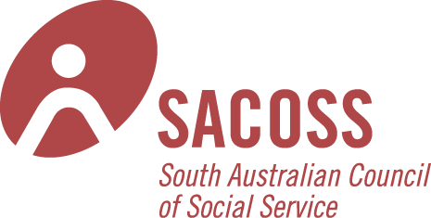
Marjorie Black House

Room Hire
All prices GST Inclusive

Marjorie Black Community Room
Seats 60 max theatre style; folding trestle tables available.
Hire cost includes laptop computer, data projector & pull down screen, whiteboard available, flat screen TV, hearing loop.
For full details see booking form.

 | SACOSS Member Rate | Community Sector  non-member rate | Government/Private
Half Day | $90 | $125 | $200
Full Day | $135 | $200 | $350
Evening | $70 | $100 | $170

Daphne Gum Room
Seats 10 around boardroom style table.
Whiteboard available, flat screen TV.

 | SACOSS Member Rate | Community Sector  non-member rate | Government/Private
Half Day | $40 | $75 | $100
Full Day | $75 | $125 | $175
Evening | $40 | $75 | $85

