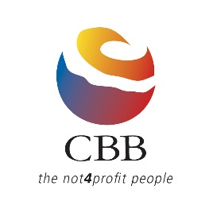

CBB Conference Scholarship Application Form
SACOSS Conference, 11 February 2014

Your name
Your position
Your organisation
Organisation location

Tell us in 250 words or less why you believe you should receive the scholarship and how you think you will benefit

Endorsed by:

Signature
Name
Position
Date

Please return your completed application by 5pm Friday 24 January to:

Att: Marissa Brown
CBB Conference Scholarship
PO Box 506 Kensington Park SA 5068
Email: community@cbb.com.au
Fax: 08 8332 2490

The successful applicant will be notified by Friday 31 January.
For further information about the SACOSS 2014 Conference, click here.

