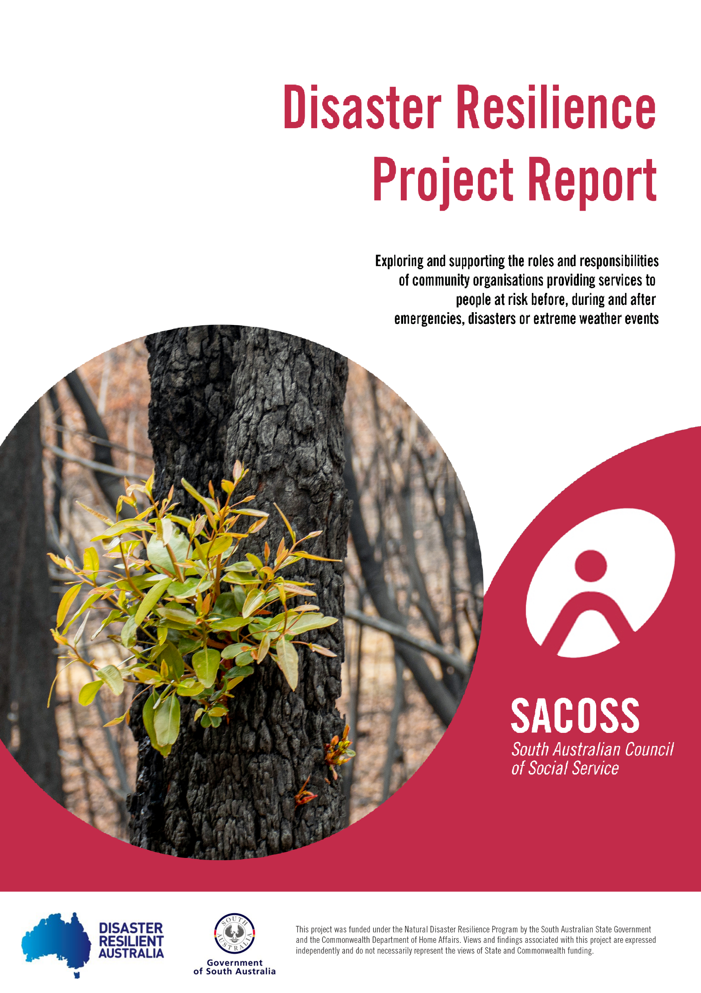

Disaster Resilience Project Report
Exploring and supporting the roles and responsibilities of community organisations providing services to people at risk before, during and after an emergency or disaster
June 2020

First published in June 2020 by the
South Australian Council of Social Service

47 King William Road
Unley, SA, 5061 Australia
Ph (08) 8305 4222
Fax (08) 8272 9500
Email: sacoss@sacoss.org.au
Website: www.sacoss.org.au

Written by Kathy Mickan, South Australian Council of Social Service.

© South Australian Council of Social Service, 2020

This publication is copyright. Apart from fair dealing for the purpose of private study, research, criticism or review, as permitted under the Copyright Act, no part may be reproduced by any process without written permission. Enquiries should be addressed to the Communications Officer, South Australian Council of Social Service.

Executive Summary
The SACOSS Disaster Resilience Project is funded by South Australian Fire and Emergency Commission (SAFECOM) to increase clarity regarding the emergency management roles and responsibilities of organisations that support people at risk, and develop tools and resources to support their work with people at risk before, during and after emergencies, disasters or extreme weather events.

This report provides a summary of the activities and outcomes of the project, the learnings from the project and identifies future priorities and work that could be undertaken to maximise the safety of people who may be at increased risk in emergencies, disasters or extreme weather events.

Phase one of the project involved desktop research and consultation to identify community need and what work is already being done to support people at increased risk before, during and after emergencies, disasters or extreme weather events, and identify what tools or resources would increase the capacity of organisations to do more or do better in the area of work. The following stakeholder type participated in the project:
- Service providers
- Funders
- Peak bodies
- Consumer representative organisations
- Consumers and
- Regulators.

The consultation results informed the next phase of the project which would include:
- Negotiate with SA Government agencies to identify the most suitable website to host disaster resilience resources for the community services sector.
- Develop guidelines for similar service types, planning tools, and a range of document templates for organisations and their boards.
- Collate a list of resources for community members that service providers can refer clients to before, during or after an emergency, disaster or extreme weather event.
- Investigate options for education for staff and board representatives.
- Identify options for annual or biannual regional meetings that include emergency services, control agencies and key service providers.
- Develop good practice case studies.

Actions were undertaken to address each of these recommendations, with the key outcomes including the development and publication of a suite of resources including:
- Emergency, disaster or extreme weather policy and procedure
- Business continuity plan template
- Responding to bushfire risk – a disability service provider case study
- Checklist of emergency management roles for providers of accommodation and housing support
- Checklist of emergency management roles for providers of centre-based services
- Checklist of emergency management roles for providers of homecare or outreach services

The SACOSS website was also updated to include comprehensive information and resources for the health and community services sector to inform their actions before, during and after emergencies, disasters and extreme weather events.

The project experienced a number of challenges over the 12 months. Two variations were made during project planning to ensure the project did not duplicate work already done by Red Cross, the objectives were evaluable, key stakeholders including people with lived experience would be included and that the appropriate project methodology would be used. While this slowed the start of the project, it also resulted in a better project being implemented. The significant fires across the state, including the York Peninsula and Cudlee Creek fires put increased demand on services and emergency management stakeholders which resulted in reduced feedback on resources and reduced participation in the project reference group. COVID-19 exacerbated these issues and reduced the efficiency of the project as time was spent learning new systems to work from home and contributing to SACOSS’ response to the pandemic. The pandemic also prevented the delivery of face to face sessions to promote the use of the tools and increase collaboration around emergency management.

There is still much work that needs to undertaken in the health and community services sector to build their capacity to address emergencies, disasters and extreme weather event in ways that maximise the health and safety of their clients, members and staff and maintain the function and viability of their organisations. The project has identified the following recommendations:

Recommendations
The following recommendations are made and may be explored by SACOSS and other stakeholders as part of future funding rounds to address disaster resilience for people who may be at higher risk in emergencies, disasters or extreme weather events:
- Partner with key stakeholders in the development of consumer resources and communication strategies for particular populations (including people living with mental illness, the deaf/blind community and Aboriginal communities).
- Advocate for funders and regulators to recognise and fund service providers addressing the needs of people at risk before, during and after emergencies, disasters or extreme weather events.
- Advocate for innovative funding options or resources to enable housing providers to make public and social housing more energy efficient to promote comfort and good health.
- SA Health further investigate/develop the concept of a text message system for communicating health warnings to people at risk and the organisations that support them.
- Identify, develop or promote a comprehensive risk assessment form that addresses a person’s exposure, sensitivity and adaptive capacity to cope with relevant emergencies, disasters or extreme weather events.
- Collate resources to create a disaster resilience toolkit for the health and community services sector.
- Build the awareness, skills and capacity of the primary health sector and consumer representative bodies to share information and strategies with their members and patients to enhance their safety before, during and after emergencies, disasters or extreme weather events.
- Work with governments to ensure equitable access to power and water subsidies for people who use higher rates of heating, cooling or water to manage their health condition.

Contents

Executive Summary i
Glossary 1
Introduction 2
Rationale 2
Project scope and context 3
Stakeholder identification 4
Stakeholder consultation 5
Consultation results Error! Bookmark not defined.
Next steps and recommendations Error! Bookmark not defined.
References 17

Glossary
Carer - a carer is a person providing unpaid care for a parent, partner, child, relative or friend who has a disability, is frail, aged, is dependent on alcohol or other drugs, or has a chronic physical condition or mental illness (Carers SA, 2020).

Consumer representative body – Consumer representative bodies are consumer representative, non-government organisations whose membership is predominantly consumers with a shared interest (eg. diabetes, heart health). As such, consumer representative bodies offer a strong voice and important integrative functions by undertaking key roles which normally include:
- Research, policy development, advice to government and their sector
- Advocacy and representation to government and other decision makers
- Information dissemination within their community and the broader public
- Sector consultation and coordination within their sector
- Sector capacity building to enable better service delivery and functioning of service providers

Disaster - A serious disruption of the functioning of a community or a society at any scale due to hazardous events interacting with conditions of exposure, vulnerability and capacity, leading to one or more of the following: human, material, economic and environmental losses and impacts. The effect of the disaster can be immediate and localised but is often widespread and could last for a long period of time. The effect may test or exceed the capacity of a community or society to cope using its own resources, and therefore may require assistance from external sources, which could include neighbouring jurisdictions, or those at the national or international levels. (AIDR, 2020)

Emergency - An event, actual or imminent, which endangers or threatens to endanger life, property or the environment, and which requires a significant and coordinated response.

Extreme weather event - Signifies individual weather events that are unusual in their occurrence (minimally, the event must lie in the upper or lower tenth percentile of the distribution) or have destructive potential. This can include a heatwave, severe storm, cyclone etc. Extreme weather events may or may not result in a disaster. For example, while a severe storm may result in significant flooding and damage to infrastructure and homes, a heat wave may be considered a disaster if the health system becomes overwhelmed, significant power outages are experienced or transport infrastructure is damaged and services fail.

Organisation – An organisation is an organized group of people with a particular purpose. In the context of this report, an organisation can include service providers, peak bodies, consumer representative bodies, advocacy groups, research organisations, government agencies or community groups.

Peak body - Peak bodies within the health and community sector are representative, non-government organisations. Their membership predominantly consists of other (legally unrelated) organisations of allied interests which are recognised by other peaks, and their sectors’ generally, as a representative of the whole of their sector. As such, peak bodies offer a strong voice and important integrative functions by undertaking key peak roles which normally include:
- Research, policy development, advice to government and their sector
- Advocacy and representation to government and other decision makers
- Information dissemination within their sector and to the community
- Sector consultation and coordination within their sector
- Sector capacity building to enable better service delivery and functioning of community organisations. (SACOSS)

Service provider – Service providers provide or carry out activities, facilities or projects for the benefit or welfare of the community or any members who have a particular need by reason of youth, age, infirmity or disablement, poverty or social or economic circumstances. The focus of this project has been not-for-profit service providers, however service providers may also be government agencies or for-profit businesses.

Stakeholder - A person, group or organization that has interest or concern in an organization. Stakeholders can affect or be affected by the organization's actions, objectives and policies.

Introduction
The SACOSS Disaster Resilience Project was funded by SAFECOM for a period of 12 months form July 2019 to June 2020. The purpose of the project was to increase clarity regarding the emergency management roles and responsibilities of organisations that support people at risk, and develop tools and resources to support their work with people at risk before, during and after emergencies, disasters or extreme weather events.

The project was managed by a Senior Project Officer at 0.8FTE and supported by a Project Reference Group.

Rationale
Changes to our climate will have implications for every area of our lives – our work, food production and food security, access to water, energy production and use, where we live, home design and sustainability, our health and mental health.

The rate of change to our climate is happening faster than many scientists had forecast. Australia is experiencing warmer temperatures and longer hot spells which can cause more dust storms and fires. A reduction in rainfall is forecast but the rainfall is expected to occur with greater intensity, raising the risk of flooding. The rising sea level is expected to put some coastal properties and environments at risk of erosion or inundation (CSIRO 2019).

The impacts of changes in our environment are felt most by people living with the highest levels of disadvantage, who are less likely to have their homes and possessions insured against fires, floods and storm damage, and who live in poorer quality housing where they will struggle to regulate extreme temperatures in summer and winter. Power outages caused by extreme weather events have a significant impact on people who live with a disability or illness that makes them dependent on power to breathe, mobilise or live independently. People living with disabilities and chronic conditions can have difficulty coping with extreme heat conditions, or sudden temperature changes, and can be made more unwell if exposed to poorer air quality due to dust storms and smoke from fires (WHO 2018). People who are socially isolated and lack family support may not have the capacity to plan for, respond to, or recover well from emergencies, disasters, or extreme weather events.

Failure to address the impact of our changing climate on people who are at higher risk in emergencies would increase disadvantage and put lives at risk. South Australia tends to have less sudden impact weather events than other Australian states. However we already have the highest number of heat-related deaths per capita of any Australian state or territory (SA Government 2019).

The Lancet and Medical Journal of Australia collaborated on the inaugural Australian Countdown assessment of progress on climate change and health, acknowledging that climate plays an important role in human health (Beggs etal, 2019). Australian research has identified:
- significant linear associations between exposure to higher temperatures and greater mortality,
- statistically significant associations between heatwaves and mortality, and
- in warmer states and territories, higher mean annual maximum temperatures predict elevated suicide rates (Zhang et al, 2018).

We are facing a future where the demand on services in an emergency may exceed the capacity to respond (SA Government 2019). Volunteering rates across Australia are declining for the first time in 20 years (SA Government 2019) and falling volunteerism is impacting many sectors, including emergency management. There is a role for federal, state and local governments, community service providers, the business sector and community members in ensuring the needs of those most at risk in emergencies are addressed before, during and after emergencies.

Community organisations play an important role in building the resilience of the people and communities they work with to minimise the potentially devastating impacts of emergencies, disasters and extreme weather events.

Project scope and context
The SACOSS Disaster Resilience Project took place in the context of work that has been, and is being, undertaken across South Australia and nationally. The South Australian government recently released Stronger Together: South Australian’s Disaster Resilience Strategy 2019-2024. Australian Red Cross has played a leadership role in supporting communities during and after emergencies and disasters for more than a century. In recent years, they have had an increasing focus on preparation and resilience building to minimise the impact of disasters and enable successful recovery. Their work included the development of a People at Risk in Emergencies Framework for South Australia. SACOSS would like to acknowledge the excellent work that Red Cross has been undertaking in communities across South Australia. This SACOSS project has been designed to build upon that work.

The purpose of the SACOSS Disaster Resilience Project was to develop clarity around the roles and responsibilities of organisations that support people who are at increased risk in emergencies, disasters and extreme weather events, and to develop tools or resources to assist organisations in this work.

The project addressed the needs of people who may be at higher risk due to poverty, poor health and mobility, disability, social isolation, communication barriers and lack of access to reliable transport.

Significant consultation was undertaken, including meeting with funding providers, peak bodies and service providers. The lived experience perspective was gained through an online survey, telephone interviews with individuals and meetings with consumer representative bodies.

The type of emergencies, disasters and extreme weather events addressed through the project includes those that are influenced by our changing climate and most relevant to South Australia. Issues such as terrorism or significant cyber security events were not included.

Project Oversight
The Senior Project Officer reported to the Director, Policy and Advocacy and established a Project Reference Group comprising representation from:
- SA Fire and Emergency Commission
- Red Cross
- SA Health
- Department for Human Services
- ac.care
- Life Without Barriers
- Lived experience representative
- SACOSS

Terms of Reference were established, and 4 meetings scheduled across the duration of the project.

Stakeholder identification
Everyone experiences being at risk at different points in our lives. This means the extent to which we can prepare for, cope with and recover from emergencies also changes from time to time (Australian Red Cross 2018). There are however some population groups that are over-represented in the injuries and fatalities that result from emergencies, disasters or extreme weather events. SAFECOM has funded projects to address the needs of homeless people sleeping rough, culturally and linguistically diverse communities and people experiencing financial hardship and SA Health and the aged care sector have undertaken a significant piece of work relating to hospitals and residential aged care facilities.

Given the ground already covered, SACOSS targeted service providers that work with people who live with disabilities, isolation, physical and mental health conditions, those who are frail aged and living at home, or people in supported accommodation. Further, we engaged with the major funders and peak bodies of those service sectors and some regulators of those service sectors. The emergency services sector was also engaged and consulted through the project. Finally, the lived experience perspective was considered essential to the project, so people who are living with factors that lead to them requiring more support in emergencies and their related consumer representative bodies were engaged.

Given the limited resources of the project, it was only possible to get representation from a small number of services across each sector - the list of stakeholders is far from exhaustive and can be found in Appendix 1.

Project Planning
The Senior Project Officer was appointed in early July 2019 and developed a project plan and recruited stakeholders to form a Project Reference Group.

The project planning process identified some concerns with implementing the project as stated in the grant application. Two project variations were submitted in July and September to:
- ensure the project did not duplicate projects already undertaken by Red Cross
- make the objectives more appropriate and evaluable
- include people with lived experience as key stakeholders
- change the methodology from being place based to one that included consultation with funders, peak bodies and regulators (these organisations are not generally located in regions)

The evaluation framework was developed to enable effective project evaluation against the objectives.

The Project Reference Group provided feedback on the Project Plan and Evaluation Framework and signed off on each.

Stakeholder consultation
Stakeholder engagement was generally undertaken via face to face meetings. A survey guided the questions and conversation, with the Senior Project Officer completing the survey form and taking additional notes throughout the conversation. Lived experience engagement took the form of an online survey using Survey Monkey. Survey respondents were invited to participate in a telephone interview to provide further information about their experience of emergencies, disasters and extreme weather events, including the services they accessed, and their recommendations about future service responses.

The second phase of consultation aimed to get feedback on the draft tools/resources. The Senior Project Officer sent each of the draft resources to six organisations that had participated in the consultation process. Each organization was sent either one or two of the resources to avoid over burdening people. Given the context of the fires and recovery process and then the COVID-19 pandemic the response rate was quite low. The Senior Project Officer then shared the draft resources via an email to SACOSS member organisations which also prompted little response, so the resources were included in the agenda of the SACOSS Policy Council. This process elicited both broad and detailed feedback.

This report includes the purpose and key consultation results. For more detail, please see the Disaster Resilience Project Consultation Report.

Lived experience
The purpose of engaging with people who may be at increased risk was to get advice and support around the engagement strategy and to identify whether people with factors that could increase their risk in emergencies had considered what they would do and who they would seek support from in an emergency, what support would be helpful to them, and any factors that were important about how organisations provided assistance.

There were 29 respondents to the survey, with three taking up the opportunity of a telephone interview. The needs of people who could be at greater risk in emergencies, disasters or extreme weather events were additionally communicated by consumer representative organisations who are informed by thousands of their members across South Australia and Australia.

Outcomes
There was diversity in the risk factors experienced by the 29 survey respondents including chronic health conditions (46%), disability (46%), mental illness (41%), frail aged (13%) and addiction (13%). Many people live with multiple morbidities and other factors that add further complexity to their ability to manage in emergencies, disasters or extreme weather events, including people bedbound or housebound by illness (23%), having no independent transport (23%), being a carer (23%) and having a preferred language other than English (5%).

Almost 80% of survey respondents have thought about what they would do in an emergency, with family being the most common source of support, but people look to family, service providers and emergency services to fulfil different support roles.

Key sources of support for specific roles
Support/assistance | Family | Service providers | Emergency services
Information so you can make your own emergency plan | 22% | 22% | 37%
Assistance to develop an emergency plan | 29% | 35% | 18%
A call to check that you are ok | 29% | 21% | 18%
Transport to get away from the emergency | 29% | 14% | 29%
Help with pets/animals in an emergency | 15% | 7% | 11%
Refuge from extreme weather | 29% | 18% | 21%
Emergency accommodation | 37% | 33% | 19%
Help accessing or storing medications | 29% | 46% | 4%
Help accessing or storing food and water | 30% | 37% | 11%
Help to clean up | 14% | 33% | 36%
Help accessing financial assistance | 30% | 67% | 0%
Help managing insurance claims | 33% | 56% | 0%
Mental health care and support | 22% | 56% | 0%
Help with the person I care for | 7% | 37% | 0%
Table 1: What sort of assistance would you like or expect, and who from?

The three interviews with people with experience of emergencies, disasters or extreme weather events identified some further considerations:
- Planning for emergencies, disasters or extreme weather events is usually focussed on the home environment. People need to be encouraged or supported to consider the risks and plan for emergencies when on holidays or away from home.
- Emergency alerts to mobile phones may recommend evacuation, however visitors to the region may have no transportation and no idea where to evacuate to, so repeated alerts particularly at night can be very alarming.
- Workshops and role-plays for people who may be at risk in emergencies and their carers could be helpful.
- Service collaboration is important. A consent form to share information in a disaster recovery centre so you can tick the services that you are happy to have your information shared with would be useful. Making people repeat their stories over and over is re-traumatising, as is making people go to multiple locations to access different services.

Service providers
The purpose of engaging with service providers was to gain insight into their understandings and practices relating to supporting clients before, during and after emergencies, disasters or extreme weather events, and what tools or resources would be helpful to support their work in emergency management. Discussions were held with 16 organisations based around a survey that was completed by SACOSS’ Senior Project Officer (henceforth SPO). A further 3 service providers engaged with the project through the SACOSS Policy Council. The organisations represented the following sectors:
- Aged care
- Disability
- Mental health
- Housing and homelessness
- Drug and alcohol services
- Aboriginal health

Outcomes
Key points identified through the service provider consultation include:
- 80% are aware of their contractual obligations, with most indicating they do not have any contractual obligations in relation to emergencies, disasters and extreme weather events, with the exception of homelessness services supporting people living rough.
- 90% believe they have an ethical responsibility to support people around emergencies, disasters and extreme weather events, with the highest level of obligation was reported by organisations providing homelessness services or home care.
- 68% of service providers have policies and procedures in place to guide their response in relation to providing services to clients at risk as a result of emergencies, disasters or extreme weather events.
- 55% indicated awareness of how to prepare vulnerable clients or community members for natural disasters or extreme weather events, with planning for fire in regional areas most common.
- 53% of participating service providers collaborates with other NGOs, emergency or state services or both before a disaster, 74% during a disaster and 53% after disasters.
- There is a lot of variance in the response of organisations before, during and after emergencies, disasters or extreme weather events.

Service provider rates of engagement in emergency management
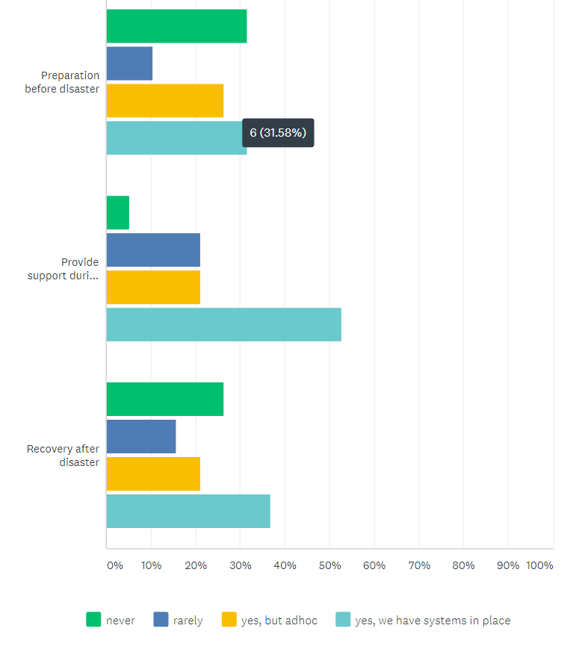

Figure 1: To what extent does your service work with clients to address disaster or extreme weather events?

Organisations were asked “What tools or resources would make it easier for you to incorporate disaster preparation, response and resilience into your everyday business”? There were a variety of responses, with the most popular being:
- A website with all the relevant information and resources in one place (61%)
- Guidelines for similar service types (56%)
- Templates (policy, business planning, intake forms etc) (44%)
- Planning tools (emergency planning) (44%)
- A network of organisations they could meet with before peak disaster seasons (44%). This item was particularly favoured by organisations working in regional areas.

The other tools identified by respondents as being useful included:
- SMS messaging campaign (4 respondents)
- Government program providing solar panels on public/ community housing in exchange for organisations providing air conditioners (3 respondents)
- Improved cooling and energy efficient housing for the sector
- Interest free loans to install sprinklers in/on roofs
- Staff education
- Networking across the homeless sector to learn what others are doing
- Mapping program that that enables organisations to overlay client locations with CFS/ SES mapping and automatically alerts clients in a high-risk region
- Assessment tool to be used nationally to categorise people at risk
- Apps that are useful and do not steal data
- Directive from funders and resources to do this work
- Access to information resources to build campaign materials for Aboriginal communities.

Consumer Representative Bodies
The project engaged with consumer representative organisations in acknowledgement that the lived experience consultation was limited, and to get a better picture of the potential human impact of not providing sufficient support to people at risk before, during and after emergencies or extreme weather events. Consumer representative bodies are often also providers of services and information to people at risk and therefore can play an important role in improving the safety of people at risk in emergencies.

The consumer representative bodies engaged with the project through face to face, telephone or network meetings. Ten of these were based around the service provider survey. The consumer representative organisations consulted represented health and illness specific groups, carers, disability, older people and people from culturally and linguistically diverse communities.

Key points identified through the consumer representative body consultation include:
- 72% are aware of their contractual obligations before, during or after emergencies, disasters or extreme weather events, with most indicating they did not have any contractual obligations.
- 80% did not believe they had an ethical obligation because they are providers of information rather than being involved in direct service delivery.
- 20% of consumer representative bodies have policies or procedures in place to guide their response in relation to providing services to clients at risk as a result of emergencies, disasters or extreme weather events, with 40% having policies and procedures in place for staff and volunteers.
- 35% of respondents prepare clients for disasters or extreme weather, mostly this is through information provision and recommending use of Telecross Redi.
- 20% have systems in place for providing support during disasters, with 60% indicating they never do this work.
- No participating consumer representative organisations have systems in place to provide support after emergencies, disasters or extreme weather events.

Peak bodies
The purpose of engaging with peak bodies was to get a broad perspective on the roles, responsibilities and practices of organisations within their respective sectors. The engagement was focused on how organisations supported clients before, during and after emergencies, disasters or extreme weather events. Through this we aimed to find out if their sector had already undertaken work relating to emergency management, and whether they would be prepared to promote the outcomes of this project to build the capacity of organisations within their sector. Discussions were based around a survey that was completed by the Senior Project Officer.

Face to face meetings were held with the following peak bodies:
- SA Network of Drug and Alcohol Services
- Aged and Community Service Australia
- Aboriginal Health Council of SA
- National Disability Service
- Shelter SA
- Mental Health Coalition of SA

Key findings from the peak body consultation include:
- 83% of peak body participants did not believe their member organisations would have a contractual obligation to support clients before, during or after a disaster, however 66% said they do have an ethical obligation.
- None of the peak bodies currently provide any support, guidance or education to member organisations to build their awareness or capacity to take a planned approach to responding to natural disasters or extreme weather events.
- SA Health and Aged and Community Services have previously undertaken a large piece of work to prepare hospitals and residential aged care facilities for disasters.
- The homelessness sector has addressed extreme weather, facilitated by SA Housing Authority.

The tools or resources that peak bodies considered would be useful to support their sector to engage in disaster management include:
- SMS messaging campaign and warnings (5 respondents)
- Education for staff on identifying or assessing risk and disaster planning (3 respondents)
- Help with bushfire plans for individuals and local areas (local collaboration) (2 respondents)
- Identifying risks specific to the mental health sector
- Education for boards and executives
- Start the conversations, terminology and definitions – disaster/emergency/extreme weather event
- Questions on intake forms to identify if clients have an emergency plan and to consent to sharing their information in emergency situations
- There should be accreditation requirements relating to preparing and supporting clients for disasters or extreme weather events

Funders
The purpose of engaging with funders was to identify whether funding providers have an expectation that service providers respond to the needs of their clients before, during or after emergencies, disasters or extreme weather events, and whether these expectations are implied or explicit in their contracts. They were also asked about funding for organisations that had provided additional services in response to a disaster, and whether they anticipated any change to the way they fund organisations to address the needs of clients before, during or after emergencies, disasters or extreme weather events.

Meetings were held with the following funders:
- SA Housing Authority
- Department for Human Services
- SA Health
- Adelaide Primary Health Network (telephone)
- Country SA Primary Health Network
- Department for Health
- National Disability Insurance Agency

Most of the funders do not refer to emergencies, disasters, or extreme weather events. in their service agreements and have no expectations that service providers will provide services relating to their client’s needs as they relate to weather related disasters or emergencies.

SA Housing Authority provide the highest level of expectation, as they fund the Code Red/Blue program to meet the needs of homeless people sleeping rough in extreme weather conditions. They also expect services to prioritise the needs of the people most at risk, and this includes people at risk from the weather conditions.

The Department of Health does have expectations of the aged care sector relating to emergency management with a focus on continuity of service. There is a requirement for people with Continuity of Support Individual Support Packages, that the service agreement should outline emergency support arrangements, including arrangements for emergency support outside of business hours. The emergency situations referred to may include the service being unable to continue providing care for the client, client exhibiting challenging behaviour, clients’ primary carer being temporarily unable to care for the client, service cancellation or support worker not turning up, and extreme weather events. There are no directions or recommendations about how to deliver these requirements to an acceptable standard.

Other stakeholders
Other stakeholders were engaged in the project because of their roles in regulation, disaster resilience and connection to workforce. These other stakeholders engaged include:
- Office for the Chief Psychiatrist
- Local Government Association
- Local Government Community Services Managers Network
- Volunteering SA
- Australian Services Union
- Australian Association of Social Workers
- NDIS Commission
- Aged Care Quality and Safety Commission

Consultation of other stakeholders confirmed that many organisations are trying to do ‘their bit’ in relation to responding to the needs of clients before, during or after emergencies, disasters or extreme weather events however there is no overarching coordination, funding or regulation.

For further information on the results of the consultation of other stakeholders, please see the full consultation report.

Consultation findings and outcomes
The consultation process informed the development of a set of recommendations about next steps for the project and other recommendations for actions that were outside the scope of this project. They are outlined below and include commentary about any actions taken:

- Negotiate with SA Government agencies to identify the most suitable website to host disaster resilience resources for the community services sector.

The Project Officer met with DHS to discuss any resourcing that may be available for a website. This process identified that there would be very little resourcing available, and if anything, it would be for a collation of useful links on a single page. SACOSS has made improvements to our current Disaster Resilience Project web page to meet this need.

- Develop guidelines for similar service types, planning tools, and a range of document templates for organisations and their boards.

Guidelines, planning tools and templates have been developed and circulated to project stakeholders, uploaded to the SACOSS website and promoted to SACOSS members.

- Collate a list of resources for community members that service providers can refer clients to before, during or after an emergency, disaster or extreme weather event.

The SACOSS disaster resilience web page includes information and links to resources for clients and community members

- Investigate options for education for staff and board representatives.

An organisation was approached regarding education options for staff and board members but there was no response.

- Identify options for annual or biannual regional meetings that include emergency services, control agencies and key service providers.

Two options for joint meetings were identified and discussed with stakeholders as potential options – Zone Emergency Management Committees which could invite key service provider participation once or twice annually, and Interagency Network meetings that operate in some regions and include SAPOL, Child Protection, Community Mental Health and may include some other key service providers, but could invite CFS and SES to participate once or twice annually. Further exploration or implementation of these options could occur in a future project.

- Develop good practice case studies.

One case study was developed featuring Community Living Australia and their approach to bushfire risk and is included on the SACOSS website.

Further recommendations were made that were outside the scope of this project. They can be found in the consultation report.

Project outcomes and learnings
The following is commentary on the outcomes of the Disaster Resilience Project and reflections and learnings on the process.

Aim
The project aim of clarifying the roles and responsibilities of community service organisations who provide regular services to people at risk within the context of emergency management has been achieved. The consultation with service providers, funders and regulators identified that the homelessness sector funded through SA Housing Authority has obligations that are implemented through activating Code Red/ Code Blue, and prioritising homeless people most at risk. Aged Care Sector home care providers also have responsibilities, but they are poorly articulated, mostly related to business continuity planning and not specifically reflected in regulatory processes. No other service providers have any contractual obligation to address the needs of their clients before, during or after emergencies, disasters or extreme weather events. Most services providers do believe they have an ethical obligation to provide supports and many do their best, but the lack of funding results in adhoc, uncoordinated approaches.

Objectives

The objectives of the project were achieved:
- organisations that support people at risk have increased clarity around their roles and responsibilities in emergency management.

The Disaster Resilience Project Consultation Report documented the responsibilities (or lack of responsibilities) of service providers to respond the needs of their clients before, during or after emergencies, disasters or extreme weather events. This report has been circulated to all stakeholders, including service providers and their peak bodies, and has been published on the SACOSS website.
The inclusion of funders and some regulators was very valuable in achieving this objective. Had the project continued with the place-based methodology as originally planned, it is unlikely these stakeholders would have been included.

- organisations that support people at risk have access to tools and resources that will support their role with their clients before, during and after a disaster.

Tools to inform decision around the roles that service providers want to undertake to address the needs of their clients before, during and after emergencies, disasters or extreme weather are now available to service providers so this objective has also been achieved.
Throughout the consultation, peak bodies demonstrated a willingness to host events with their member organisations to promote the project resources and promote enhanced collaboration and knowledge sharing across their sector. Due to the COVID-19 pandemic this has not happened. SACOSS will offer to work with the peak bodies to achieve this prior to the next fire season to keep the issue of disaster management on the agenda of service providers and maintain awareness of the resources.

Project Oversight
The project reference group was established in the first quarter of the project with most, but not all positions filled by the first meeting in September 2019.

The purpose of the reference group was to assist the Disaster Resilience Senior Project Officer with strategic advice, including but not limited to:
- feedback on the work plan
- ways to encourage sector organisations to engage in the project
- guidance to negotiate working with others engaging the sector for similar purposes
- advice for project evaluation
- problem solving issues that arise as the project is implemented
- guidance on planning for sustainability and next steps at the conclusion of the project.

Due to a couple of instances of annual leave and 2 positions not being filled, the first meeting was attended by only 2 external stakeholder members. The Senior Project Officer then met individually with other members to familiarise them with the project plan and terms of reference, and to get feedback on those documents.

As a result of the project variation to add people with lived experience as project stakeholders, a person with lived experience was recruited to the reference group. A second service provider organisation was also recruited by the November 2019 meeting. This meeting however was also poorly attended for a number of reasons, including 4 of the members being in the Emergency Control Centre during the York Peninsula fire. Two external stakeholders attended the meeting. The Senior Project Officer used out of meeting follow-up to endorse project documents and the terms of reference.

The December fires across South Australia, including the Cuddlee Creek and Kangaroo Island fires also had a major impact on the workload and focus of many of the reference group members, reducing their availability to provide comment or feedback on the Draft Consultation Report.

Emergency management also impacted on attendance at the March 2020 meeting, as state control agencies were planning lockdown measures as a result of the Coronavirus pandemic. This meeting was cancelled with six apologies.

The impact of these events and then subsequent staff changes resulted in some agencies not attending any of the first three reference group meetings and feeling that their involvement in the final meeting would be redundant.

Although a number of members of the reference group provided useful advice between scheduled meetings, it is not felt that the reference group was able to achieve its purpose, largely due to the impact of fires and coronavirus on the availability and workloads of reference group members.

Stakeholder management
The stakeholder identification process led to a major restructure of the project- adding people with lived experience, funders, peak bodies, consumer representative bodies and some regulators as project stakeholders and therefore moving away from a place-based methodology. These changes to the initial proposal are considered to have positively influenced the project and its achievement of objectives.

The purpose of stage one consultation was to identify the expectations of consumers, funders and regulators and the current practices, capacities and needs of service providers as well as to identify tools, resources or strategies to support. The consultation was well organised, effectively achieved its purpose and was successfully documented. The number and spread of stakeholders consulted was sufficient for the purpose and scope of this project.

Conclusion
Emergencies, disasters and extreme weather events are increasing in their frequency and intensity, and people who live with poverty, are isolated or experience other conditions that impact on their ability to plan for, respond to, or recover from these events without support are most impacted.

Research and consultation undertaken throughout the project identifies the following as being important to people with lived experience of factors that could increase their risk in emergencies, disasters or extreme weather events:

Before a disaster
- Accessible, accurate information and resources from emergency services and service providers to empower them to make their own decisions and take their own actions.
- Detailed emergency plans and emergency kits, with some individuals requiring support to develop them.
- Energy efficient housing that enables them to have affordable access to heating, cooling and water to maintain comfort and health.
- Good social support from family, friends or service providers.

During a disaster
- Effective communication and telecommunications to inform their decision making. Power and telecommunications were down during the Black Summer bushfires, leaving people with disabilities feeling isolated and unable to access support, including people who were blind and could smell smoke and had no idea how close the fire might be.
- Reliable transport to escape a disaster.
- Places of refuge from extreme weather events, particularly for those who are homeless or have poor quality housing.
- Accessible evacuation centres that address the needs of people with a range of disabilities, assistance dogs, medication storage.
- Emergency housing

After a disaster
- access to financial assistance, help to manage insurance claims and access to mental health support.
- assistance to clean up after a disaster
- Ongoing engagement activities and support

This project has developed information and resources for the sector to support the efforts of the health and community services sector to address the needs of their clients and community members before, during and after emergencies, disasters or extreme weather events. It has identified organisations that demonstrate excellent practice, however there is still much more to be done to embed emergency management into the standard practice of many organisations and to build collaborative approaches within and across the health and community sector and the emergency services sector.

Recommendations
The following recommendations are made and may be explored by SACOSS and other stakeholders as part of future funding rounds to address disaster resilience for people who may be at higher risk in emergencies, disasters or extreme weather events:
- Partner with key stakeholders in the development of consumer resources and communication strategies for particular populations (including people living with mental illness, the deaf/blind community and Aboriginal communities).
- Advocate for funders and regulators to recognise and fund service providers addressing the needs of people at risk before, during and after emergencies, disasters or extreme weather events.
- Advocate for innovative funding options or resources to enable housing providers to make public and social housing more energy efficient to promote comfort and good health.
- SA Health further investigate/develop the concept of a text message system for communicating health warnings to people at risk and the organisations that support them.
- Identify, develop or promote a comprehensive risk assessment form that addresses a person’s exposure, sensitivity and adaptive capacity to cope with relevant emergencies, disasters or extreme weather events.
- Collate resources to create a disaster resilience toolkit for the health and community services sector.
- Build the awareness, skills and capacity of the primary health sector and consumer representative bodies to share information and strategies with their members and patients to enhance their safety before, during and after emergencies, disasters or extreme weather events.
- Work with governments to ensure equitable access to power and water subsidies for people who use higher rates of heating, cooling or water to manage their health condition.

Appendix 1

List of stakeholders

Aboriginal Health Council SA
ac.care
Adelaide PHN
Aged and Community Services Australia
Aged Care Quality and Safety Commission
Asthma Australia
Australian Red Cross
Carers SA
Catherine House
Community Living Australia
Consumers
COTA SA
Country SA PHN
Cystic Fibrosis SA
Department for Health
Department for Human Services
Diabetes Australia
ECH
Heart Foundation
Hills Community Options
Housing Choices
JFA Purple Orange
Legal Services Commission
Life Without Barriers
Lived Experience Leadership and Advocacy Network
Local Government Association
Local Government Community Services Managers Network
MECFS SA
Mental Health Coalition SA
Mission Australia
Multicultural Communities Council SA
National Disability Insurance Agency
National Disability Service
NDIS Quality and Safety Commission
Nunkuwarrin Yunti
Office of the Chief Psychiatrist
Resthaven
SA Council on Intellectual Disability
SA Country Fire Service
SA Health
SA Housing Authority
SA Network of Drug and Alcohol Services
SA State Emergency Service
SAFECOM
Salvation Army
Shelter SA
Southern Cross Care
St Johns Youth Service
St Vincent de Paul
Uniting Communities
Unity Housing
West Coast Homecare

References

Australian Institute for Disaster Resilience, Commonwealth of Australia, 2020, Australian disaster resilience knowledge hub.

Australian Red Cross 2018, People at risk in emergencies framework for South Australia

CSIRO 2019. Case study: Climate change information for Australia https://www.csiro.au/en/Research/OandA/Areas/Oceans-and-climate/Climate-change-information

Paul J Beggs, Ying Zhang, Hilary Bambrick, Helen L Berry, Martina K Linnenluecke, Stefan Trueck, Peng Bi, Sinead M Boylan, Donna Green, Yuming Guo, Ivan C Hanigan, Fay H Johnston, Diana L Madden, Arunima Malik, Geoffrey G Morgan, Sarah Perkins‐Kirkpatrick, Lucie Rychetnik, Mark Stevenson, Nick Watts and Anthony G Capon, 2019
Med J Aust || doi: 10.5694/mja2.50405, The 2019 report of the MJA–Lancet Countdown on health and climate change: a turbulent year with mixed progress

SA Government 2019, Stronger Together: South Australia’s Disaster Resilience Strategy 2019-2024

World Health Organisation 2018, Climate Change and Health, https://www.who.int/news-room/fact-sheets/detail/climate-change-and-health

Ying Zhang, Paul J Beggs, Hilary Bambrick, Helen L Berry, Martina K Linnenluecke, Stefan Trueck, Robyn Alders, Peng Bi, Sinead M Boylan, Donna Green, Yuming Guo, Ivan C Hanigan, Elizabeth G Hanna, Arunima Malik, Geoffrey G Morgan, Mark Stevenson, Shilu Tong, Nick Watts and Anthony G Capon 2018, The MJA–Lancet Countdown on health and climate change: Australian policy inaction threatens lives Med J Aust 2018; 209 (11): 474. || doi: 10.5694/mja18.00789

